 | St Nicholas Church School, Bath & Wells Academy  Ash Walk, Henstridge, BA8 0QD  Executive Headteacher: Mr James Webb  Head of School: Mr Chris Pavey  01963 362308  Enquiries@henstridgestnicholas.bwmat.org

Friday 26th September 2025

Year Three/Four Residential Experience – Booking Information

Dear Parents/Carers,

We are pleased to announce the Year Three/Four Residential for this academic year.

This year’s residential trip will be to Kilve Court in the Quantock Hills. Click Kilve Court for more information on the site

We will be travelling to Kilve by coach, approximately an hour and a half away – the residential will be from Monday 9th March (start of school day) to Tuesday 10th March (end of school day).

I will be hosting a presentation on Thursday 2nd October at 3.20pm in Ladybird Class. If you are unable to join us then, the presentation is on our website Residential Trips - St Nicholas Church of England VC Primary School. If you have any questions please do just ask.

Abbas and Templecombe’s Previous years’ trips to Kilve Court have been great fun and memorable experiences for all the children; please see below for details of this 2 day, 1 night residential experience.

The cost will be £110 and includes:
- 1 night full board accommodation, including meals, drinks, etc.
- Coach travel (funded by school)
- A great range of adventurous, geographical and sports based activities
- Evening entertainment
- Bedding, for example a sleeping bag / duvet and pillow.

Our activities will be:

Low Ropes | Climbing |  | Grass Sledging
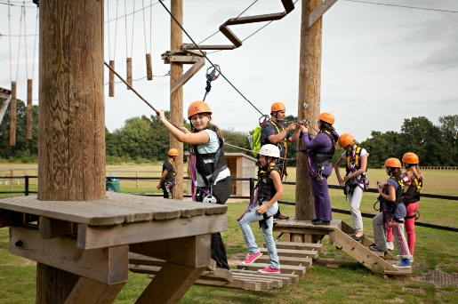 | 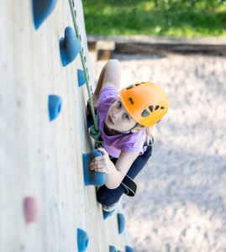 |  | 
Shelter Building |  | Super Teams
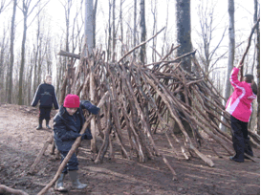 |  | 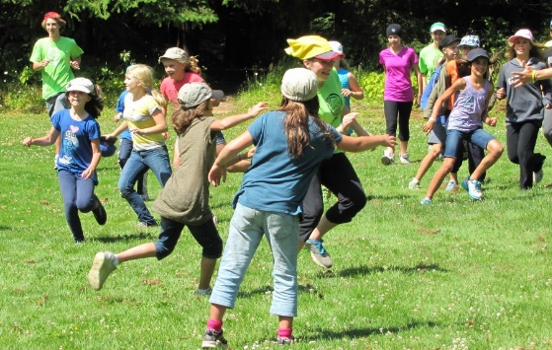

And lots, lots more…

Where we will be staying:
Kilve Court is a Georgian country house with modern extensions, situated in 40 acres of wooded grounds and gardens. It is a well-established residential site catering for schools and children’s groups that we have stayed at many times before. It is run by Somerset Services for Education. We will be using the onsite caterers with the day starting with cereals and a cooked breakfast, lunch is packed and provided (apart from arrival day); there are a couple of choices for the evening meal with a yummy pudding to follow. Dietary needs are met and are always catered for. Squash and cake/fruit are supplied at break times during the day. They promise that children never go hungry at Kilve Court.

We will be sleeping in our own accommodation area in large bunk-bedded rooms. The bedrooms sleep up to 12 children. Boys and girls will not be allowed in each other’s rooms and will have separate toilets and showers. We will also have use of a large indoor space for eating and playing, if the weather is not favourable. School staff will be supervising children at all times and any outdoor, adventurous activities will be supervised by qualified instructors. Staff have their own bedrooms interspersed between the children’s.

The Accommodation:
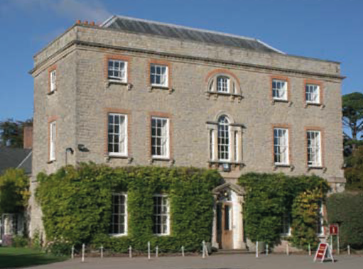 | 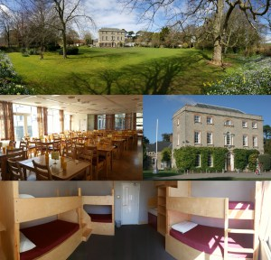  The rooms
 | The site
The cost of this residential is based on all pupils attending and could alter very slightly depending on uptake (£5). Any child not attending will be expected to attend school and will be in another class for the duration of the trip.

The payment deadlines are:
You are welcome to make payments of any size and at any point along this timeline - as long as you fulfill the minimum amounts.
            - 7th November 2025 - £25 – Deposit (non-refundable)
            - 5th December 2025 - £40 – 2nd payment
            - 6th February 2026 - £45 – Final payment

Please understand that, by signing up for the Kilve Court trip, you are agreeing to meet the payment deadlines set out above - the school cannot cover the cost of any missed payments and the deposit is non-refundable. If at any point you are struggling to make a payment please contact the office so they can discuss a way forward with you.

Please use the Arbor Parent Portal (Quick Actions/Trips) to give your consent and pay the £25 deposit no later than Friday 7th November to confirm your child’s place. We have access to a special fund for pupils that are or have recently been in receipt of Free School Meals. If this applies to your child, please do contact Mrs Bendoraitis to find out about the assistance we can provide towards these payment amounts.

Please access this link https://forms.office.com/e/WifnkuyxxP to read and agree the Behaviour Code of Conduct, give permission for your child to attend the Residential and opt in or out of permission for images / videos to be taken and shared.

We very much hope that your child will be able to come on this excellent trip.

Mr J Webb

Executive Head Teacher / Educational Visits Co-ordinator

