English
Reading: The Invisible & James and the Giant Peach
- Children will have daily vipers and phonics sessions and weekly guided reading sessions, to develop word reading, comprehension skills and to build on vocabulary.
- Read on a daily basis
Through a variety of fiction, non-fiction texts and poetry, children will:
Year 3:
- Discuss the meaning of word and language in poems
- I watch performances of poems and stories
- I compose sentences using a wider range of structures linked to the grammar objectives.
- I increase legibility of my handwriting and join
- I spell words from the Year 3 and 4 word list
- I use adverbs and conjunctions effectively in my writing
- I begin to organise paragraphs around a theme
Year 4:
- I recognise and name different types of poems which have been introduced to me
- I enjoy watching performances of poems and stories
- I increase the legibility of my handwriting and join
- I spell words from the Year 3 and 4 word list
- I begin to use fronted adverbials, nouns and pronouns in my work
- I begin to open paragraphs with topic sentences and organise them around a theme
- I almost always use commas for fronted adverbials
Music
Children will:
Exploring Descriptive Sounds - create, perform and analyse short descriptive compositions that combine sounds, movements and words.
Listen to traditional Spanish music
Children learn a Spanish song and sing in Spanish in MFL

Geography

Children will explore two locations – Spain (Barcelona/Catalonia) and Greece Children will:
- Locational knowledge: pupils locate Europe on a world map and globe. They locate Europe in relation to the UK and its surrounding oceans and countries.
- Place knowledge: consider how the size of Europe might affect people’s experience of Europe.
- Human and physical geography: pupils locate Europe and consider the land area of the country/continent. They compare this to the area of other countries and continents.
- I know why people may be attracted to explore
- I can name some European landmarks


PE
This term, children will be playing ball games and creating their own PE game. We will also complete the Golden Mile on a daily basis.
Children will:
-know and use rules fairly
-be aware of space and use it support team-mates and cause problems for the opposition
-vary tactics and adapt skills depending what is happening in the game
French /Spanish
The children will revise current French learning
- I have a short conversation saying 3-4 things
- Children will learn their numbers in french
- Children will learn some key Spanish phrases
PSHE
Exercise
Children will practise using their DNA-V skills to understand their own physical activity, including tracking the consequences of their exercise behaviour, and using Values to guide what they do.
Self-Care
Children explore the concept of self-care in terms of eating a balanced diet, using the Noticer and Advisor to spot and manage risks and dangers, and how to seek help and support from others.
DT
Children will:
- Taste and make Greek and Spanish food.
- Design and make Greek Jars/Vases

Art
Children will explore the artist’s Picasso and Dali.
Children will:
- I know how to use different grades of pencils to shade and to show different tones and textures.
- I know how to use sketches to produce a final piece of art.
- I know how to create a background using a wash.
- I experiment with the different styles used by other artists.
- I recognize when art is from different cultures
- I know how to sculpt clay and other mouldable materials.

Computing
Using the IPads and Chrome books, children will:
- Use scratch
- Make a power point or fact sheet on teeth (science link)
- E-Safety and safely search online
- Understand what the terms Anti-Bullying and Cyberbullying mean

Maths
- Place Value
- Addition and Subtraction
- Multiplication and Division
Through these areas, the children will develop their fluency, problem solving and reasoning skills.
Children will complete weekly times table tests and end of unit tests, to check understanding.
Science
Forces and Magnets (3)
- Explore forces and motion
- Sort magnetic and non-magnetic materials
- To learn about attract, repel and the magnetic poles
Animals Including Humans (4)
- Types and functions of teeth
- Erosion on teeth
- Digestive system
Children will work scientifically through first hand experiences to: ask relevant questions, to set up a test to compare two things and I know how to set up a fair test.

RE

We will focus on our Christian values;
- Autumn A – Friendship and Trust
- Autumn B – Perseverance and Courage

Christianity – What is important to me?
Children will also have daily collective worship and prayer

Curriculum Intent:
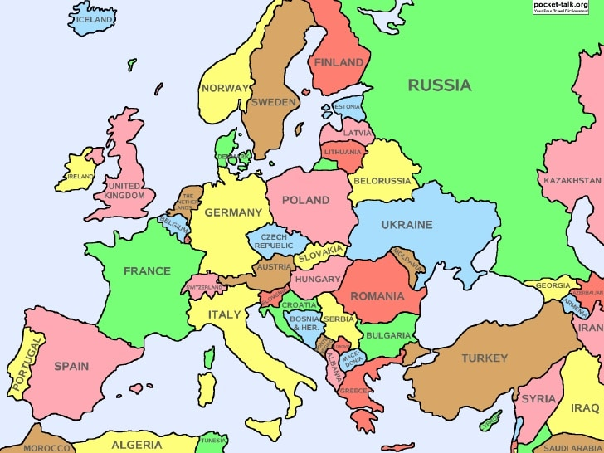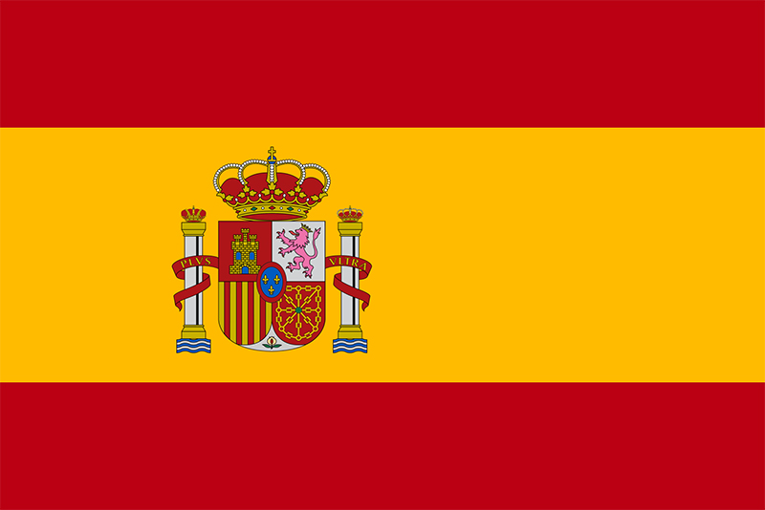
Continent focus: Europe
Key Focus: Spain and Ancient Greece
Please see our class page for photographs of the children’s learning experiences.

History

This term the children will learn about Australian traditions and where they originated from

- I know at least three landmarks in Barcelona.
- I know about Sir Francis Drake and his life
- I know who invented the Olympics
- I can create a timeline of events about Ancient Greece
- I know the history of Ancient Greece
- I can learn about the Greek Gods

During comprehension and guided reading sessions the children will learn about Spain and Greece in more depth.

