English
Reading: Goodnight Mister Tom
- Children will have daily vipers sessions and guided reading sessions, to develop word reading, comprehension skills and to build on vocabulary.
- Read daily.
- Children will apply their growing knowledge of root words, prefixes and suffixes through daily spelling practise.
Through a variety of fiction, non-fiction texts and poetry, children will:
- Make comparisons across texts.
- Write poems and prepare to perform them.
- Check that texts make sense, draw predictions, make inferences and summarise what they’ve read by engaging in daily group reading comprehension.
- Write legibly, fluently and with increasing speed to produce:
  - Poetry
  - Letters
  - Autobiographical work
  - Fiction
  - Chronological and non-chronological reports
  - Newspaper reports
  - News bulletins
Music
Children will learn about:
- Metre
- Rhythm

Geography

Children will:
- Locate the world’s countries, focusing on Europe.
- Understand and compare geographical and physical features of areas in the UK and internationally.
- Explore topographical features.
- Use maps and globes to navigate and locate areas and geographical features.


Curriculum Intent:
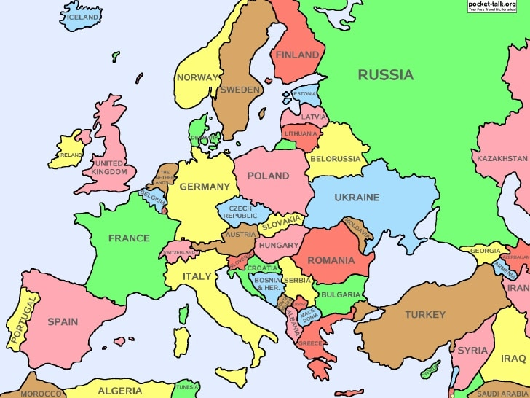
Continent focus: Europe
Key Focus:
Please see our class page for photographs of the children’s learning experiences.

PE
This term, children will be We will also complete the Golden Mile on a daily basis.
Children will learn:
- Rounders
- Basketball
- Athletics
- Gymnastics
- Swimming

French
- Learn basic conversational phrases and use them in conversation.
- Learn and use vocabulary including days of the week, months, seasons, colours, clothes and animals.
PSHE
Exercise
Self-Care

DT
Children will:
- Use various resources to create landscapes

Art
Children will:
- Learn about artists from across Europe
- Take inspiration from European artists and create their own work
Computing
Using the IPads and Chrome books, children will:
- Understand how to communicate over the internet safely.
- Create a webpage.

Maths
- Place Value, Addition and Subtraction, Multiplication and Division and Fractions
Through these areas, the children will develop their fluency, problem solving and reasoning skills.

Science
Light and Electricity
- Parts of the eye
- How eyes receive and process light
- Luminous and non-luminous objects
- Light pollution
- How light travels in a straight line

RE

We will focus on our Christian values;
- Discussing identity
- Considering how stories, songs and prayers communicate religious messages
- What it’s like to be a Christian
- Compare and contrast religions

History

This term the children will learn about

- World War II
- Life pre-1066
- Anglo-Saxons, Vikings, and the Battle of Hastings
During comprehension and guided reading sessions the children will learn about World War II in more depth.

