English at St. Nicholas C of E Primary
English  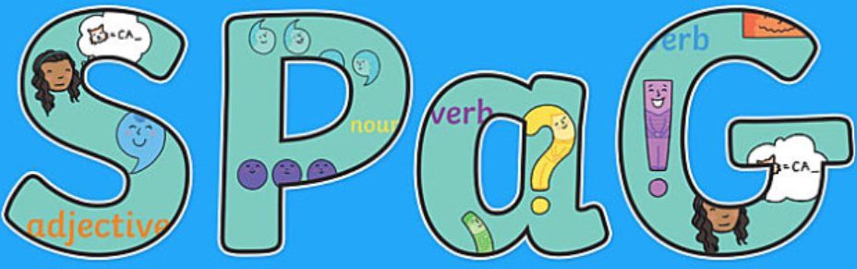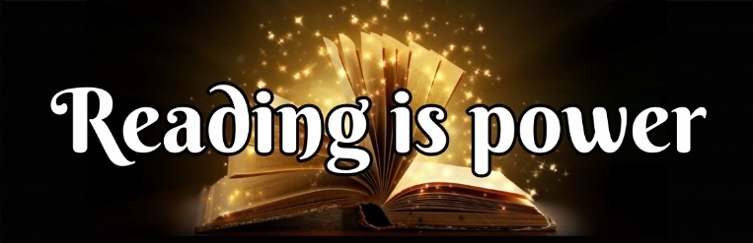 | What is English?  English consists of vocabulary, grammar, functions, reading, listening, speaking, and writing.  Why is English so important?  English will teach children to speak, read and write fluently so that they can communicate their ideas and emotions to others, and through their reading and listening, others can communicate with them.  Which careers are linked to English?  Teacher, author, reporter, writer, publisher to name just a few.
Key Concepts:  - Speaking and Listening  - Reading  - Writing    - Comprehension  - Transcription  - Vocabulary  - Punctuation  - Grammar | What will I learn about?  - Reading – Vipers & Reading Comprehension  - Writing – narratives, diary entries, letters etc…  - Spelling – weekly and termly tests  - Punctuation  - Grammar  - Phonics - FFT

