Writing at St. Nicholas C of E Primary
Writing  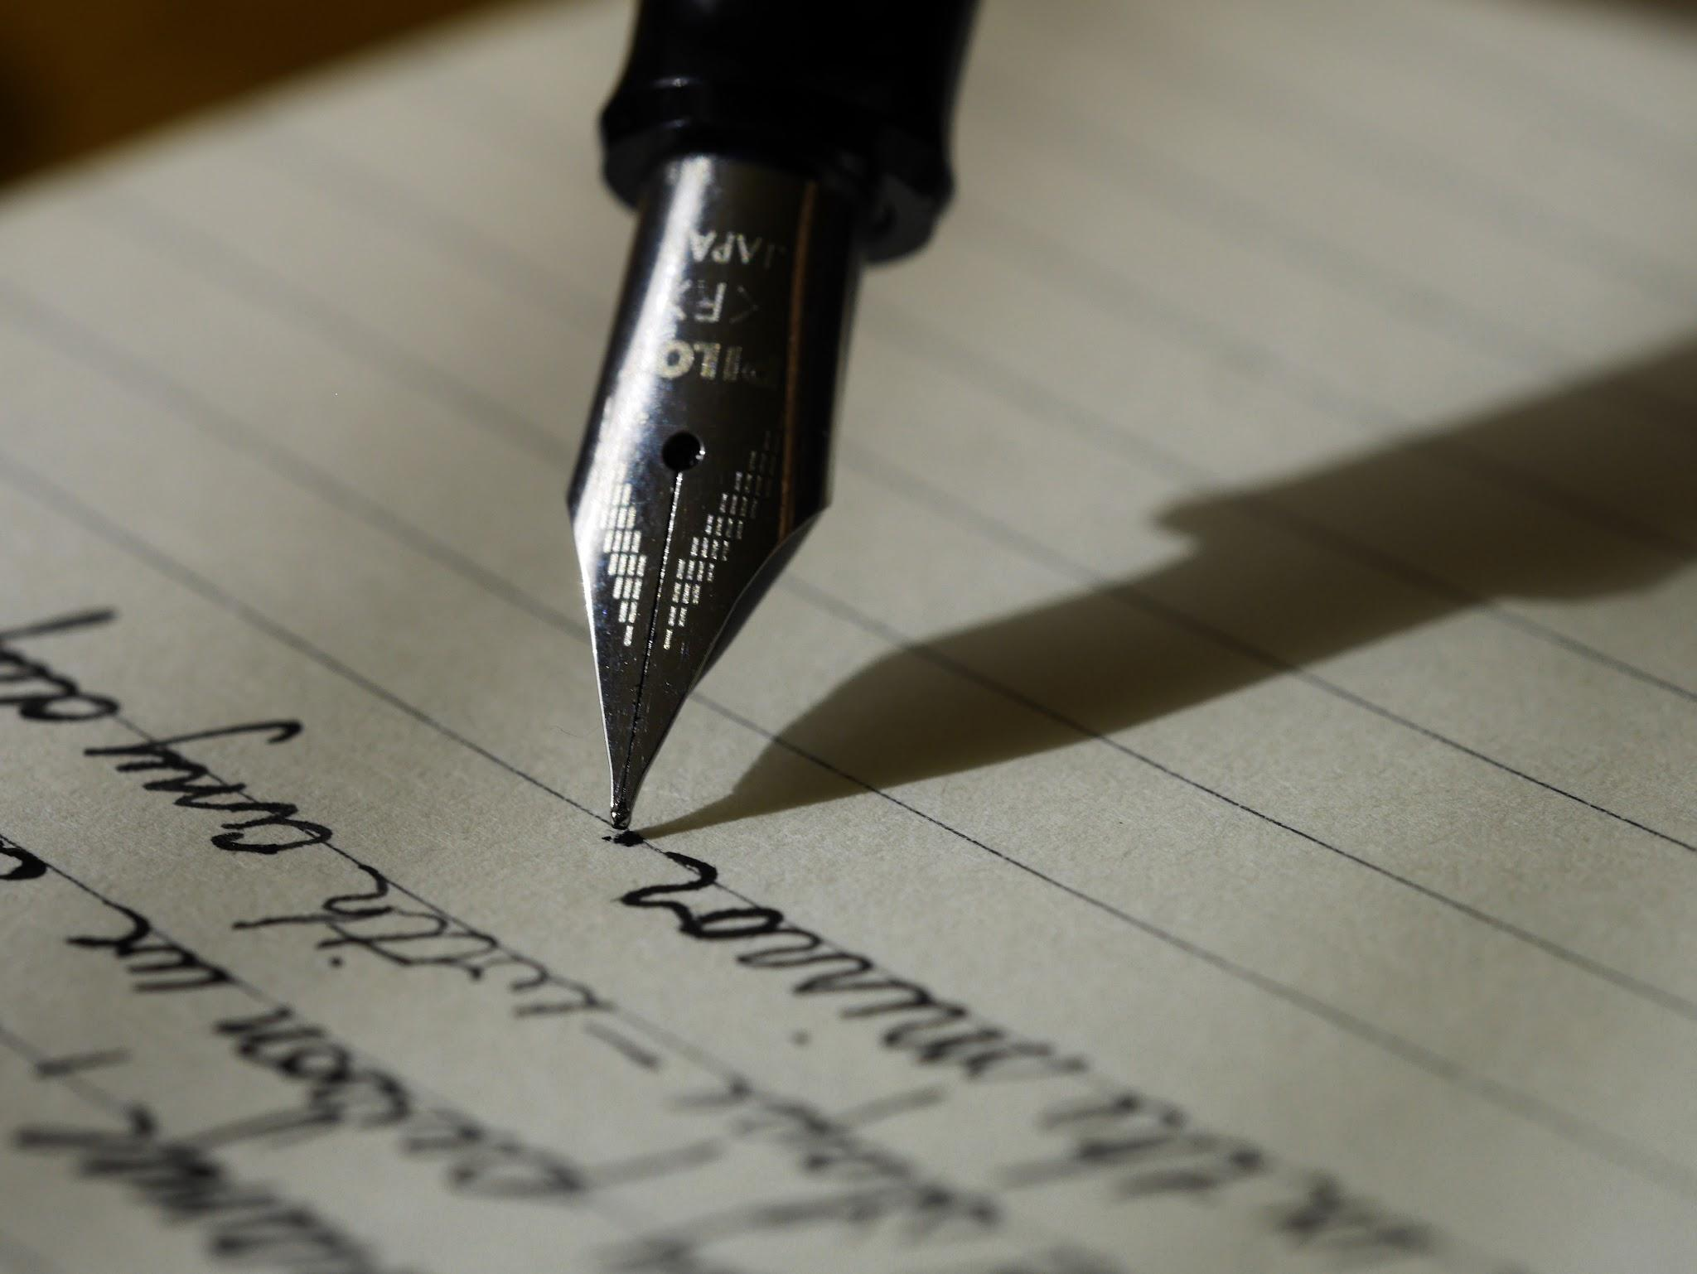 | What is Writing?  Writing is the recording of information using letters and words. This could be information (non-fiction), a story (fiction) or poetry.  Why is Writing so important?  Writing is how information has been recorded for thousands of years and is the reason that we can build on knowledge. A good understanding of writing is essential to be understood.  Which careers are linked to Writing?  Nearly every job will require writing in some form- particularly teacher, scientist, author, manager, journalist, to name a few.
Key Concepts:  - Phonics    - Handwriting  - Spelling  - Vocabulary  - Sentences  - Genre | What will I learn about?  - Vocabulary  - Text structure  - Sentence construction  - Word types  - Clauses

