History at St. Nicholas C of E Primary
History  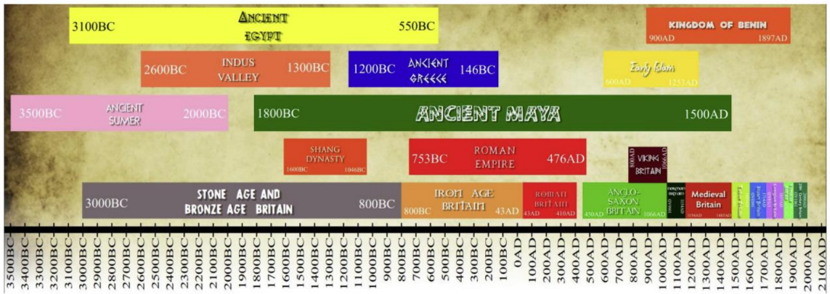 | What is history?  In history you learn about the past in Britain and the wider world and its impact on how we live today.  In history you examine evidence and consider things from different points of view.  Why is history so important?  History helps us to understand people’s lives and how societies work together.  Which careers are linked to geography?  Author, archaeologists, television presenter, broadcaster, teacher, museum worker, explorer, palaeontologist, to name just a few.
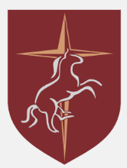  Key Concepts:  - Chronology  - Invasion  - Empire  - Democracy | What will I learn about?  - Changes within living memory  - Lives of significant individuals  - Significant historical events (e.g. WWII)  - Changes in Britain–Stone Age to Iron Age  - Roman Empire  - Settlements of Anglo Saxons  - Early Civilisations – Ancient Egypt, Maya  - Ancient Greece

